Marketing Research
Baby Dolls
- Aori 17 Inch Baby Dolls Realistic Doll with Ultra Real Life Soft Body & Pink Outfits for Girls 3+ | Pretend Play, Dress Up, Nursery Decor
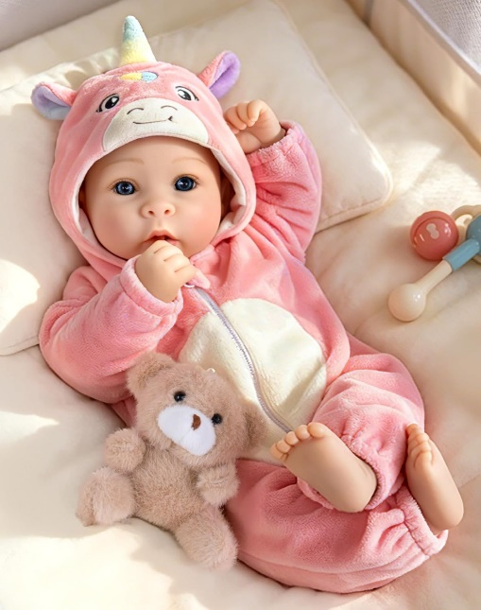

Price: LKR 8,284.
Colors: Fire Fox, Grey Koala, Purple Bunny, Pink Unicorn
Product Details:
- Realistic Head & Limbs - Soft vinyl head and hands/feet with lifelike details – delicate fingernails, rosy cheeks, and realistic skin folds for an authentic baby-like touch. Cloth body ensures cuddly comfort.
- Spray-Painted Hair for Enhanced Realism - Featuring finely spray-painted hair with natural-looking texture and color, adding to the doll’s lifelike appearance without shedding or tangling.
- Premium Hybrid Material Construction - Soft vinyl head and hands & feet paired with a cotton body and plush stuffing – perfectly balanced for both realism and huggable softness.
- Hug-Friendly Design - 17-inch size with cloth limbs makes it easy to carry. Lightweight yet sturdy for long-term play and cuddles.
- Developmental Pretend Play - Encourages nurturing skills, empathy, and creativity through role-playing as caregivers – perfect for "mommy & me" games or sibling bonding.
- Safety-Certified & Child-Friendly - Meets ASTM F963 and CPSIA standards: Non-toxic soft vinyl + hypoallergenic fabric. No small detachable parts – safe for ages 3+.
- Ready-to-Gift Premium Set - Includes: 1 doll + 1 outfit + 1 birth certificate + 1 bottle + 1 pacifier + 1 diaper. Beautifully packaged for birthdays, Christmas, or adoption day surprises.
Customer reviews
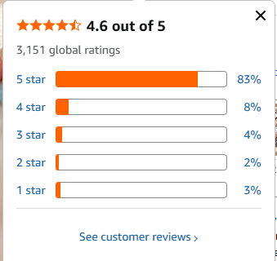

https://www.amazon.com/Aori-Realistic-Outfits-Pretend-Nursery/dp/B0F5TWR4ZR/ref=sr_1_3_sspa?crid=K4V2ZXCDEQ53&dib=eyJ2IjoiMSJ9.dRDwBI7d-yua71KdminMtOc4UcSdv1I6ZScfLvXjmu5-fHLs4yW5iJuD4G4aEZHFByk4EheiRa1bc_hSRsSQcT1K1wQf_D-tB3TAUp22fQKgT7qg0HB5aCTcXrMhg1VZH4lbnKrHrRU3j4n4runSmfYvq9cOPFSOJDPcZwryFtg6AgMnHSiA_t_nSKfcQb_y4_3mwqTSCUlKixFkc-YKjXpfofqzYlkSOqXEcrNBTKVS8vtPP--85OEcLR98vWNBzICb1K1Me0UxN1v2oeOTgOYua53fta9CNpcpo3Klr6U.8YNKd9D4sZqKh2ouiZAK2lpU6N_4_MYNKnFTy0aHs4o&dib_tag=se&keywords=dolls&qid=1780380715&refinements=p_n_g-1001308730111%3A2569825011&rnid=2569813011&sprefix=dolls%2Caps%2C368&sr=8-3-spons&sp_csd=d2lkZ2V0TmFtZT1zcF9hdGY&th=1

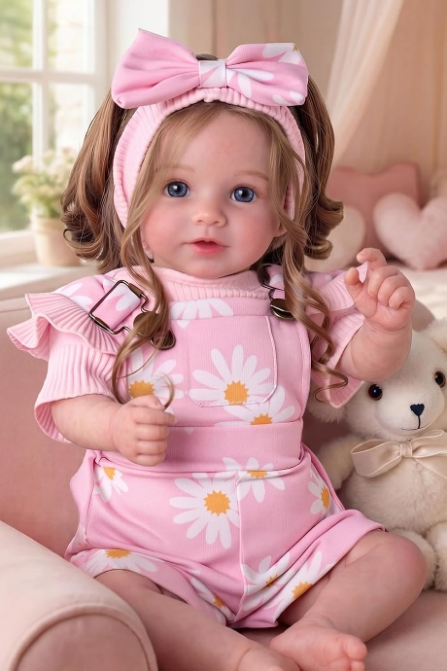
- BABESIDE Reborn Baby Dolls, 20Inch Soft Cloth Body Realistic Baby Doll w/Rooted Hair and Open Eye Reborn Doll for Girls Real Life Baby Dolls Perfect for Kids Ages 3+, Playtime and Collection

Price: LKR14,914.
Product Details:
- Unbelievably Realistic: This 20-inch reborn baby doll boasts hand-painted details, soft rooted brown hair, and bright blue eyes, creating a lifelike experience. With her cozy cloth body, she’s perfect for snuggles and endless playtime fun
- Endless Playtime Fun: This reborn doll is all about imaginative play! Kids age 3+ can feed, change, and care for her, boosting their creativity and teaching them responsibility through every nurturing moment
- Your Little One’s New Best Friend: Perfect for girls aged 3 and up, this realistic baby doll makes the best companion—whether it’s for bedtime cuddles or playful adventures, she’ll be there for it all
- Built to Last, Safe for Play: Crafted from safe materials, this real-life baby dolls are made to withstand hours of play without losing her charm. She’s as safe as she is durable, offering a true-to-life experience that lasts
- The Perfect Gift for Any Occasion: Whether for a budding doll collector or a child’s first baby doll, this life like baby dolls that look real makes the ultimate gift. Her adorable outfit and life like features are sure to make her the star of any collection
Customer reviews
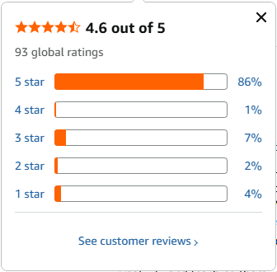

https://www.amazon.com/dp/B0FDFF1YKW/ref=sspa_dk_detail_1?psc=1&pd_rd_i=B0FDFF1YKW&pd_rd_w=sembW&content-id=amzn1.sym.85ceacba-39b1-4243-8f28-2e014f9512c7&pf_rd_p=85ceacba-39b1-4243-8f28-2e014f9512c7&pf_rd_r=X9ABG4G6M6DW7P9KGM7H&pd_rd_wg=5uSYv&pd_rd_r=cebe28e2-db53-4636-bd89-ea9535fa6cc4&sp_csd=d2lkZ2V0TmFtZT1zcF9kZXRhaWxfdGhlbWF0aWM

- BABESIDE Baby Doll Girl, 15" Realistic Baby Doll with Blue Eyes, Soft Body in Unicorn Outfit Real Life Baby Dolls for 3+ Years Girl, Birthday Gift and Pretend Play
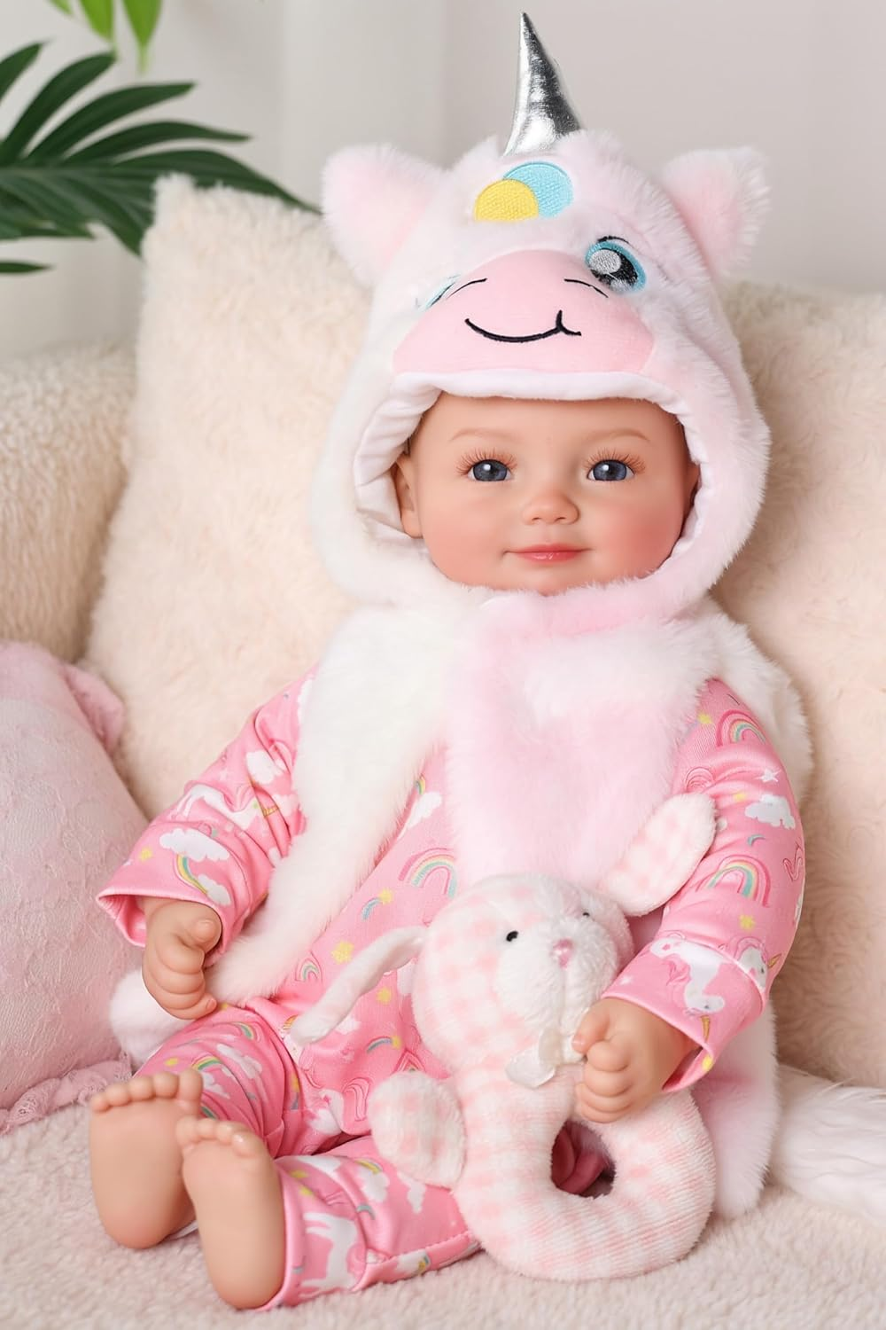

Price: LKR 6,626.
Product Details:
- Realistic Baby Doll: Designed to introduce little ones to nurturing play, Sena features soft vinyl skin with realistic details that look and feel just like a real baby—perfect for hugs, cuddles, and first-time doll experiences
- Lightweight and Easy to Hold : At 15 inches tall and lightweight in design, Sena is the ideal size for kids to carry, hold, and snuggle. Encourages independent play at home or on the go
- Encourages Emotional Development: Kids can role-play feeding, comforting, and caring for Sena—helping build empathy, responsibility, and social interaction skills while having fun
- Complete Starter Set: Includes everything your child needs for immersive play: a feeding bottle, magnetic pacifier, and a customizable birth certificate to name their new baby
- The Perfect Gift: Thoughtfully packaged and ready for gifting. Whether for birthdays, holidays, or just because, Sena offers a meaningful, screen-free play experience that blends fun with early childhood learning

Customer reviews
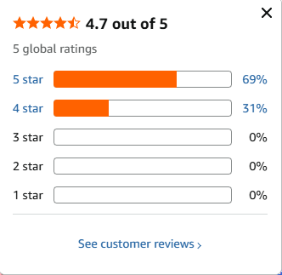

https://www.amazon.com/dp/B0FBFXC373/ref=vp_d_cpf-substitute-widget-prsubs_pd?_encoding=UTF8&pf_rd_p=3b384b6f-3e1a-4384-bf9e-527aad01ce71&pf_rd_r=X9ABG4G6M6DW7P9KGM7H&pd_rd_wg=uhNNY&pd_rd_i=B0FBFXC373&pd_rd_w=0oOFW&content-id=amzn1.sym.3b384b6f-3e1a-4384-bf9e-527aad01ce71&pd_rd_r=8cb4a9e4-0b36-41a9-bef0-18cd73276c1b&psc=1

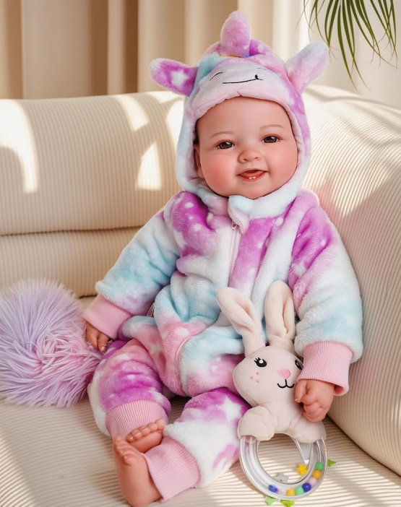
- BABESIDE Baby Dolls, 17inch Large Realistic Cute Soft Body Baby Doll Real Life Baby Dolls with Accessories for 3+ Year Old Girls Gifts, Pretend Play, Collection

Price: LKR 7,949.
Colors: Pink, Blue, Off-White
Product Details:
- More Life-like Realism: Experience the joy of cuddling with a doll that feels just like the real thing! Our 17-inch big baby doll is easier to hug and hold. With hand-rooted eyelashes, delicate baby-like fingernails, and realistic folds on its tiny hands and feet, the rosy cheeks add to its charm, making it a delightful addition to any doll collection
- Irresistibly Cute and Soft: With its endearing smile and poseable limbs, this baby doll is guaranteed to capture your heart. Her head is made of premium vinyl materials with a cloth body and limbs, soft to the touch, ensuring hours of cuddly fun for your little one. Plus, its durable construction means it can withstand all the love and playtime your child can give
- Inspiring Imagination and Play: Whether your child enjoy pretend play, role-playing as a parent, or simply having a buddy to accompany them during the day, this new born baby doll fits the bill. It's also great for stimulating children's imagination and fostering creativity. Beyond playtime, it's an ideal collectible for doll enthusiasts of age 3+
- Exciting Accessories for Interactive Fun: Our toy baby doll comes with an array of accessories to enhance the play experience. It includes a bottle, magnetic pacifier, birth certificate, gift box and a cute outfit to keep things fresh and engaging, add layers of fun(not included bunny rattle)
- Perfect Gift for Every Occasion: Whether it's a birthday, Christmas or special holiday, our cute baby doll makes the perfect gift for children! Plus, it's made with safety in mind, using non-toxic materials, giving you peace of mind as your child plays and explores.

Customer reviews
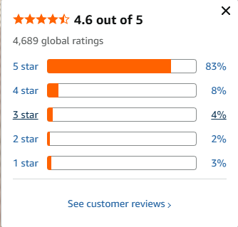

https://www.amazon.com/dp/B0DHD2CN7K/ref=vp_d_cpf-substitute-widget-prsubs_pd?_encoding=UTF8&pf_rd_p=3b384b6f-3e1a-4384-bf9e-527aad01ce71&pf_rd_r=MWC59J4TH8QM8MWEXBMG&pd_rd_wg=cuVKx&pd_rd_i=B0CY4X37RD&pd_rd_w=iW46h&content-id=amzn1.sym.3b384b6f-3e1a-4384-bf9e-527aad01ce71&pd_rd_r=5834f387-04f1-459e-8130-7eb8cec24ad8&th=1

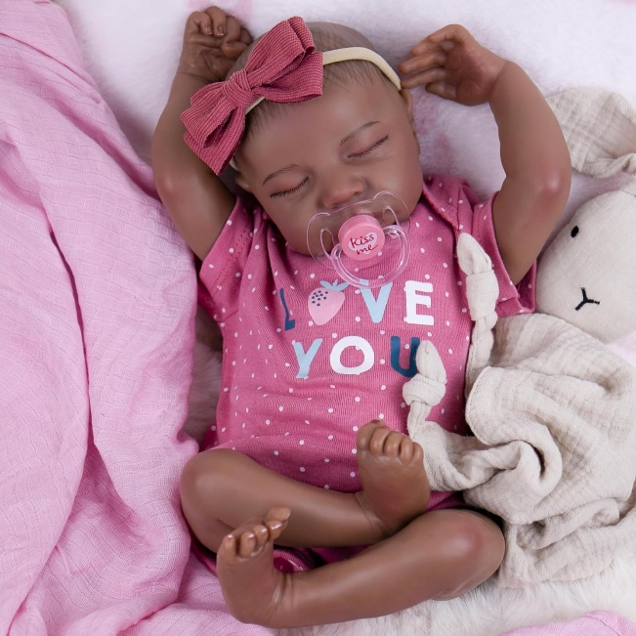
- Milidool Reborn Baby Dolls Black Girl - 18-inch Realistic Baby Dolls, Lifelike Soft Vinyl Black American Doll, Nice Gift for Kids, Pre-Parents, Grand-Parents, Doll Collectors

Price: LKR 9,444.
Colors: Nia, Aaliyah, Abigali
Product Details:
- Crafted by Hand, Made with Love: Wow, My gosh! Hand-painted reborn baby dolls black boy-Aiden, the realistic baby doll is smooth, soft, like a little newborn baby just birthed. You will be amazed by the wonderful features of real babies, meticulously hand-painted hair, hand-rooted eyelahes, realistic skin texture and a sweet, realistic expression. Holding the real looking baby dolls evoke the sensation of holding a real baby dolls that look real.
- Enjoy His Soft Body：Dive into a world of softness! Experience the comfort of a soft embrace with our black lifelike baby boy, he come with a soft cloth body, a vinyl head and 3/4 limbs. Designed for snuggles and cuddles that feel as genuine as a real baby's warmth. The weighty baby doll feels just like a real baby when you hold him.
- Realistic Baby Size: Measuring 18 inches from head to toe, the reborn dolls is perfectly sized for little hands. Easy to carry, snuggle, and take on adventures.This real looking baby doll black can be dressed up with three-month-old baby clothes to complete the realism. This silicone baby doll allows parents and kids to dress the doll in a wide range of adorable outfits.
- Safety Assurance: Our Milidool baby dolls are made from high-quality, environmentally friendly, and non-toxic materials. Safety is our top priority, and they comply with safety certifications ASTM F963 and EN71 for children aged 3 and above, ensuring a safe play experience.
- Perfect Gift: Packaged in an elegant gift box, they make for thoughtful and visually appealing presents. Whether for birthdays, Christmas, role-playing, or collecting,they bring joy to both children and adults. Can help your child develop caring and social-cognitive skills. Perfect for grandparents' accompany, reduce loneliness in the elderly.You will receive the reborn doll(x1), Clothes set as pictured(x1), Feeding bottle(x1), Magnetic pacifier(x1),Birth Card(x1), Diaper(x1)—all packaged in an exquisite gift box.

Customer reviews
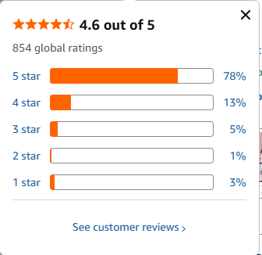

https://www.amazon.com/dp/B0FH6G8846/ref=sspa_dk_hqp_detail_aax_0?sp_csd=d2lkZ2V0TmFtZT1zcF9ocXBfc2hhcmVk&th=1

- WOOROY Realistic Reborn Baby Dolls - 18 Inch Lifelike Newborn Baby Girl, Real Life Baby Dolls with Soft Weighted Body, Real Baby Reborn Gift Set for Kids Age 3

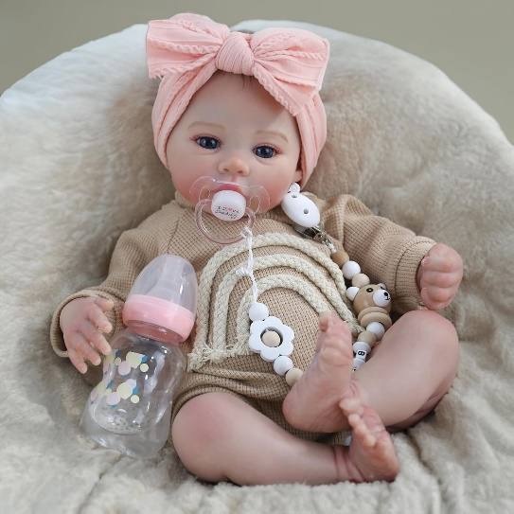

Price: LKR 13,253.
Colors: Brown, Pink
Product Details:
- Realistic Baby Dolls Girl: Our reborn baby girl doll measures 18 inches in length. She comes with lifelike baby poseable vinyl limbs and a weighted soft cloth body for a real baby feel, suitable for children to cuddle and care for.
- Exquisite Craftsmanship: This realistic newborn baby girl's skin is painted meticulously with multiple layers to achieve a true-to-life human skin effect, featuring subtle veins and a rosy hue on her cheeks, which are applied by hand for incredible realism.
- Exceptional Artistry: Each reborn doll is handcrafted by skilled artists with meticulous attention to detail. Carefully sculpted features like hand-painted hair, wrinkles, half-moon nails, and a slightly parted mouth with defined lip creases bring her to life.
- Safety Assurance: Our WOOROY realistic reborn baby dolls are made from high-quality, environmentally friendly, and non-toxic materials. Safety is our top priority, and they comply with safety certifications ASTM F963 and EN71 for children aged 3 and above, ensuring a safe play experience.
- Adorable Outfit: A cozy and stylish tan knit outfit with rainbow stripes across the front and a large, vibrant pink bow adorns the reborn doll's head. You can also change newborn-size clothes for her to make her more charming.

Customer reviews


https://www.amazon.com/dp/B0D41QZFPQ/ref=sspa_dk_detail_6?pd_rd_i=B0D41QZFPQ&pd_rd_w=oWo7Y&content-id=amzn1.sym.85ceacba-39b1-4243-8f28-2e014f9512c7&pf_rd_p=85ceacba-39b1-4243-8f28-2e014f9512c7&pf_rd_r=Y945WDW0DYX7H1KSTJZQ&pd_rd_wg=2FNe8&pd_rd_r=f206f241-39ad-4a3c-ae00-d11403e89edb&sp_csd=d2lkZ2V0TmFtZT1zcF9kZXRhaWxfdGhlbWF0aWM&th=1

- 18 Inch Reborn Baby Doll, Full Vinyl Weighted Body, Realistic Baby Doll with Soft Bunny Onesie & Rabbit Toy Accessory, Lifelike Newborn Doll for Girls 3+ Pretend Play, Nursery Décor
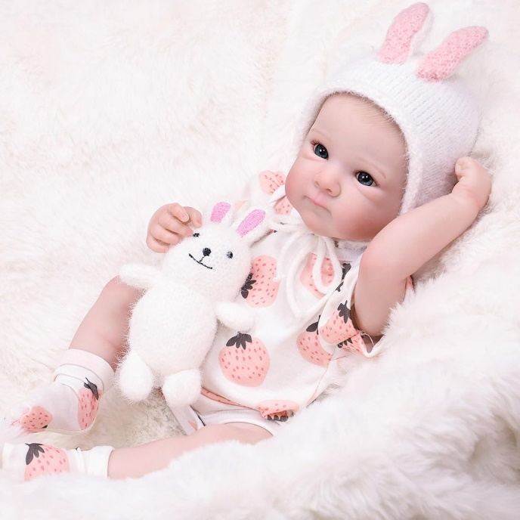

Price: LKR 17,897.
Colors: White, Light Khaki
Product Details:
- Safe and Non-Toxic Material: Our reborn doll is made of non-toxic, BPA-free materials and strictly complies with children’s safety standards, making it 100% safe for kids aged 3 and above. The smooth surface with no sharp edges prevents scratches, letting parents rest assured while their little ones enjoy fun play
- Realistic & Lifelike Newborn Experience: Our Tookyhill reborn doll Crafted with exquisitely hand-painted hair and vivid blue eyes, this reborn doll boasts lifelike facial features. The naturally blushed cheeks and tightly pressed lips (only upper lip visible) further enhance its authentic baby-like charm, bringing an immersive snuggling and companionship experience for both kids and collectors
- Realistic 18 Inch Full Vinyl Reborn Baby Doll：Measuring 18 inches long and weighing 2.3 pounds, this perfectly proportioned reborn baby girl doll is sized just right for little hands to cuddle and hold. Crafted with a full vinyl body, it features a huggable, lifelike figure and fully poseable hands & limbs—ideal for endless pretend play poses. It fits standard 0-3 month real baby clothes, letting your little one mix, match, and customize the doll’s style to their heart’s content. Comes with a coordinated adorable outfit and a cute plush bear accessory for instant play fun
- Versatile Usage Scenarios for Multiple Needs: Ideal for various occasions, kids’ pretend play (feeding, dressing, parenting role-play), adult doll collection, emotional comfort companion, or nursery decoration. It also serves as a meaningful gift for birthdays, Christmas, baby showers, and other special festivals, bringing joy to your loved ones. This doll not only a perfect playmate but also an ideal holiday gift for kids, doll collectors, or new parents
- Value Pack with Adorable Deer Hat & Toy: Comes with a cute deer-themed set: 1x cute outfit, 1x hand-knitted deer hat, 1x plush deer toy, 1x feeding bottle, 1x birth certificate, 1x diaper, and 1x gift box for a full nurturing adventure. The festive and lovely design adds a warm winter vibe

Customer reviews
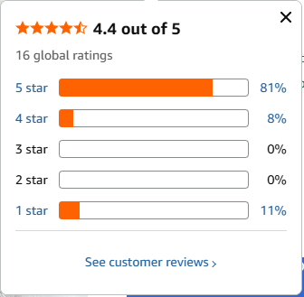

https://www.amazon.com/dp/B0G1RLNTPQ/ref=sspa_dk_detail_3?pd_rd_i=B0GCHWZ79Z&pd_rd_w=f3kPR&content-id=amzn1.sym.ac210bc5-f6e8-418c-8a77-e0c4ca3bcd7f&pf_rd_p=ac210bc5-f6e8-418c-8a77-e0c4ca3bcd7f&pf_rd_r=G72Z3MKMG3JJYAY936MN&pd_rd_wg=C7EQq&pd_rd_r=28b574a8-8be0-47f6-9ec3-29a0c3ea7102&sp_csd=d2lkZ2V0TmFtZT1zcF9kZXRhaWw&th=1

- FOCKOF Realistic Reborn Baby Dolls - 18 Inch Real Life Baby Doll Girl Lifelike with Accessories for 3+ Years Old
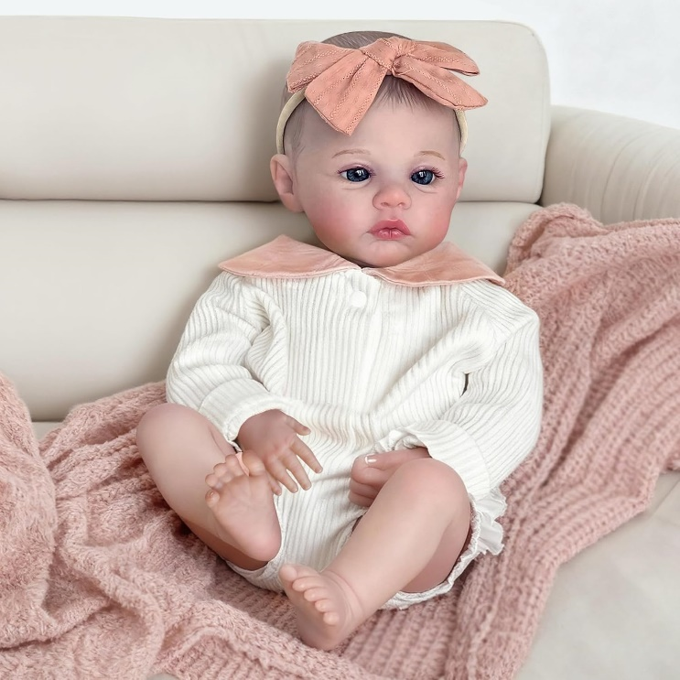

Price: LKR 9,275.
Colors: Meadow-White, Meadow-Pink
Product Details:
- Realistic Baby Doll Size and Mobility: Reborn baby doll girl measures 18 inches in length. You may change clothes for the baby doll yourself. The reborn baby limbs can be moved freely and it is totally poseable
- Reborn Doll Structure and Safety: The baby doll features a soft cloth body and hand-painted hair. Our reborn dolls are fully compliant with ASTM F963 and EN71 safety certifications for children ages 3 and up, ensuring a safe experience
- Lifelike Details and Craftsmanship: The wrinkles on chubby face, palm, and feet are carved by designer. Charming eyelashes under the hand-drawing eyebrows are installed by hand to create the most lifelike effects. Completely hand-drawn nails, redness of the nail bed and translucent nails
- Versatile Uses and Applications: Suitable for birthday present, Christmas gift, preschool activity, home activity, role play, nurse and babysitter training, granny's companion and baby doll collection. Holding this realistic looking baby doll is like holding a real baby
Customer reviews
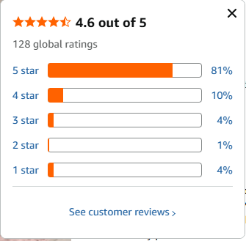

https://www.amazon.com/dp/B0DT5F2MJR/ref=sspa_dk_detail_1?pd_rd_i=B0FKSSW543&pd_rd_w=dqpDY&content-id=amzn1.sym.85ceacba-39b1-4243-8f28-2e014f9512c7&pf_rd_p=85ceacba-39b1-4243-8f28-2e014f9512c7&pf_rd_r=WY0P17QPTDAB5SH8PFDY&pd_rd_wg=f2JPu&pd_rd_r=43837b5c-87c9-4bcb-b3a8-05fd1978856b&sp_csd=d2lkZ2V0TmFtZT1zcF9kZXRhaWxfdGhlbWF0aWM&th=1

- 20-Inch Reborn Baby Doll, Cute Realistic Newborn Baby Doll with Slightly Open Mouth, Full-Body Vinyl Baby Dolls for 3+ Ages, Gifts, Emotional Healing
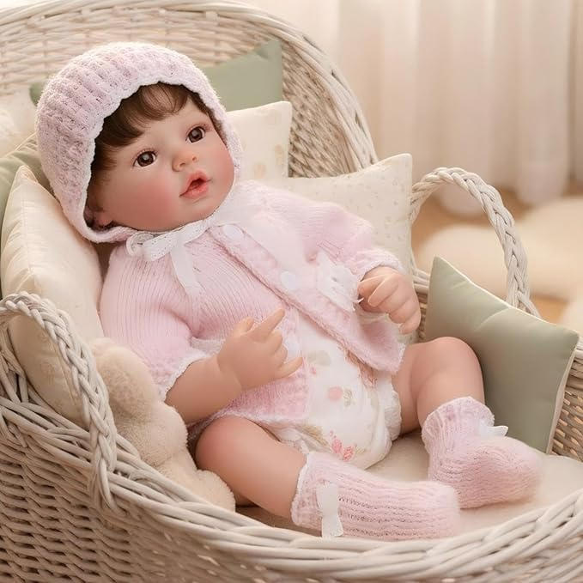

Price: LKR 6,958.
Product Details:
- 【Lifelike Reborn Baby Doll】Crafted to mimic a real newborn, this 20-inch reborn baby doll features delicately hand-painted lips, blushing cheeks, and sticky eyelashes for an ultra-realistic look that melts hearts.
- 【Unique Reborn Doll】Every reborn baby doll you purchase from colveray will be unique. The doll's face was meticulously polished by our designers, and the makeup of each doll is hand-painted. So even for the same doll, there may be slight differences. Please take back the doll that is exclusively yours!
- 【Removable Dress】The clothes we dress the dolls are all designed by professional fashion designers, and you can easily dress up by untying the straps, buttons or zippers on the doll, taking off its clothes, and then changing into the clothes you like.
- 【Safety Assurance】Cloveray newborn baby doll is made of high-quality, environmentally friendly and non-toxic materials. Safety is our top priority. They comply with CPC and TIC safety certifications and are suitable for children aged 3 and above, ensuring a safe gaming experience.
- 【Perfect Gift for Kids & Collectors】This cute lifelike baby doll makes an ideal present for birthdays, holidays, or anyone who loves hyper-realistic dolls. Great for children aged 3+ and adult enthusiasts.
Customer reviews
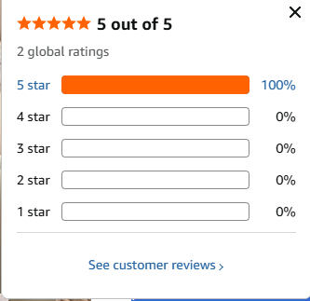

https://www.amazon.com/dp/B0FWBXSJ1C/ref=sspa_dk_detail_6?psc=1&pd_rd_i=B0FWBXSJ1C&pd_rd_w=PB1aH&content-id=amzn1.sym.85ceacba-39b1-4243-8f28-2e014f9512c7&pf_rd_p=85ceacba-39b1-4243-8f28-2e014f9512c7&pf_rd_r=9Z0QZEGJYYPKV6YW9NW5&pd_rd_wg=xfA8s&pd_rd_r=6d655e55-dcc0-4b1a-8c09-293aad84adbe&sp_csd=d2lkZ2V0TmFtZT1zcF9kZXRhaWxfdGhlbWF0aWM

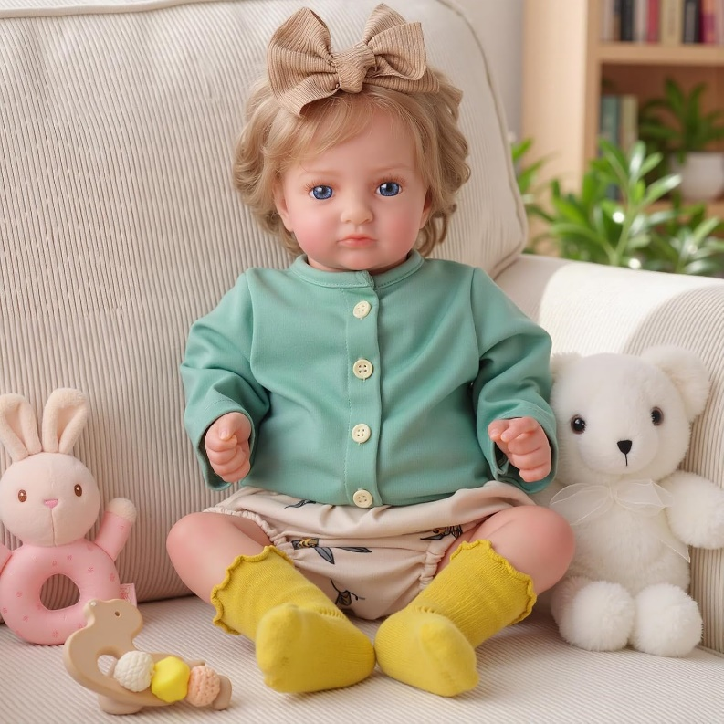
- BABESIDE Lifelike Reborn Baby Dolls - 20 Inch Realistic-Newborn Real-Life Doll Girl Poseable with Clothes for Kids Age 3+

Price: LKR 9,941.
Product Details:
- Adorably Real: With her bright open eyes and rosy cheeks, she gazes up as if she’s ready for her next cuddle. This realistic baby doll girl doll feels like a little bundle of joy waiting to be loved from the very first hug
- Handcrafted Lifelike Details: Delicately hand-rooted hair, soft hand-painted blushing, and natural creases on her tiny hands and chubby feet create stunning realism. Every feature is thoughtfully sculpted to mirror a real newborn baby’s expression and charm
- Soft Cloth Body & Vinyl Limbs: Made with smooth vinyl arms and legs and a cuddly soft cloth body for the perfect balance of realism and comfort. The lightly weighted design enhances the real life baby doll experience while staying easy for small arms to hold
- A Meaningful Childhood Companion: Fits real newborn-size baby clothes, making dress-up play even more interactive and fun. Encourages nurturing role play like dressing, comforting, and caring during imaginative playtime. Through hands-on bonding moments, children develop empathy, creativity, and a growing sense of responsibility
- Certified Safe & Trusted Quality: Crafted from premium, non-toxic materials that are gentle on little hands and skin. This reborn doll meets CPSC and ASTM safety standards for trusted performance. A thoughtful, parent-approved gift

Customer reviews
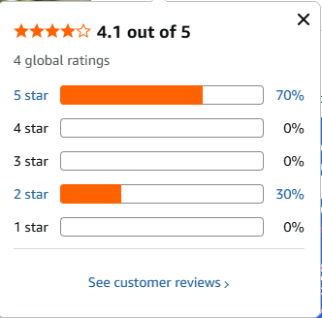

https://www.amazon.com/dp/B0GF83X9Y4/ref=vp_d_cpf-substitute-widget-prsubs_pd?_encoding=UTF8&pf_rd_p=3b384b6f-3e1a-4384-bf9e-527aad01ce71&pf_rd_r=5EMNHGZAXKTN7RAHF0J5&pd_rd_wg=pqIc3&pd_rd_i=B0GF83X9Y4&pd_rd_w=aXAkr&content-id=amzn1.sym.3b384b6f-3e1a-4384-bf9e-527aad01ce71&pd_rd_r=f9618c6b-1943-4338-ab8b-3e96b5f1be96&psc=1

